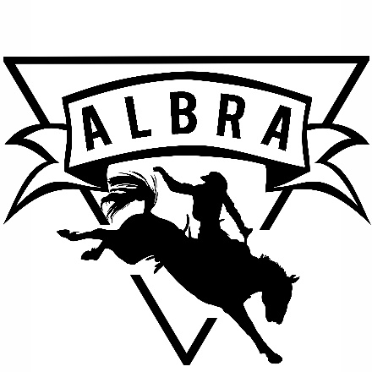

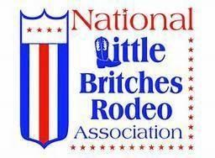
Sponsor Information

Business/Sponsor Name: ______________________________________

Address: ___________________________________________________

Phone: ___________________ email: ___________________________
Website: __________________________________________________
Contact Person: _____________________________________________
Event Sponsored (If Applicable): _______________________________
Paid: (Please Circle): Check (# ) Cash

Amount:

ALBRA Member Credited with Sponsorship:______________________
For sponsorships $250 and above, please email logo to albra.rodeo@gmail.com for arena banner printing purposes.

