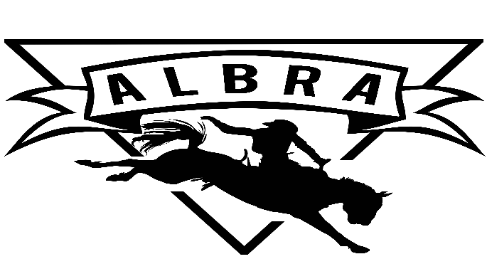

Alabama Little Britches Rodeo Association

2023-2024 Membership Application

Last Name:__________________________
Contestant 1 Contestant 2
First Name:_______________________ First Name:______________________
Date of Birth:______________________Date of Birth:_____________________
Division: TH LW JR SR Division: TH LW JR SR
Male Female Rookie Male Female Rookie
Signature:________________________ Signature:________________________

Contestant 3 Contestant 4
First Name:_______________________ First Name:______________________
Date of Birth:______________________Date of Birth:_____________________
Division: TH LW JR SR Division: TH LW JR SR
Male Female Rookie Male Female Rookie
Signature:________________________ Signature:________________________

Parent(s)/Guardians:__________________________________________________
Address:____________________________________________________________
Phone:____________________________ Email:___________________________
Parent(s)/Guardians Signatures:_______________________________________________

~~~~~~~~~~~~~~~~~~~~~~~~~~~~~~~~~~~~~~~~~~~~~~~~~~~~~~~~~~~~~~~~~~~~~~~~~~~~~~~~~~~~~~~~~~~

Office Use Only
Membership: Single $50 Family $75 CASH CHECK#__________ DATE:_______________
Release: COMPLETE
Sponsorship: Single $100 Family $200 CASH CHECK#_________ DATE:_______________
Work Card(s) Buy Out Wk Cd $500 2023 ~~~~~~ Work Card(s) 2024 Buy Out Wk Cd $500 2023

Raffle Contestant 1 Raffle Contestant 2
Raffle Contestant 3 Raffle Contestant 4
Member Good Standing: COMPLETE
By signing the membership application I/We understand and agree it is my/our responsibility to read the NLBRA Rulebook & ALBRA Ground Rules and abide by them.
Membership application & Release must be completed and notarized. Bring paperwork and dues (cash or check) to first rodeo.
Dues must be paid before points will count $75.00 Family membership ($50.00 if only one contestant).
Every contestant is responsible for obtaining a minimum $100 sponsorship. Families of two or more contestants are responsible for a minimum of a $200 sponsorship. Due by December rodeo.
Every contestant must sell a minimum of 8 raffle tickets. Due by April rodeo.
Every Contestant is responsible for turning in two work cards with 20 initials each from the director of the event. One is due August-December & one will be due January-April. Families will be required four work cards. Two August-December & two January-April. Work cards above the required minimum will be entered in a separate drawing.
Contestants must compete in one more than half of the total ALBRA rodeos per event that occured in that season, to be eligible for year end awards in that event. To be eligible for All Around Awards contestant must compete in more than one event. Rookies (first year competing & being a member with ALBRA) competing in more than one event and competing in one more than half of the rodeos during the season will be eligible for the Rookie All Around Award.
Membership must be paid before points will count towards year end awards. Points will not be retroactive and will begin only when current and full membership is obtained. Members must be in good standing to receive awards.
Entry Fees are due by postmark deadline. If deadline is missed you will have to call rodeo secretary to see if entries are still being accepted. All late entries will pay a fee per rodeo.

Alabama Little Britches Rodeo Association

Parent/Guardian Release of Liability
ALBRA and any of their associates are released from all liability when attending and/or participating in any events associated with the ALBRA.

We, , the parents or legal guardians of the above
named child/children, do hereby give our permission for him or her to participate in the 2022-2023
ALBRA rodeo series. We also release the ALBRA from all liability caused from injury or accident while at a ALBRA event.

_______________________________________________ |  | _________________________
Father’s Signature |  | Date
_______________________________________________ |  | _________________________
Mother’s Signature |  | Date
Year-End Award Requirements Acknowledgement

We, , the parents or legal guardians of the above
named child/children, do hereby acknowledge that we are aware of the ALBRA year-end award requirements as stated in ALBRA membership application.

______________________________________________ _________________________
Father’s Signature Date

______________________________________________ _________________________
Mother’s Signature Date

State of ________________________
County of ______________________
Subscribed and sworn to me this _______ day of _______________________, 20____
By ________________________________________________________
Witness my hand and official seal.
My commission expires ____________________________. ______________________________________________________________
Notary Public

Please bring to rodeo signed and notarized no membership will be excepted with out it being notarized

