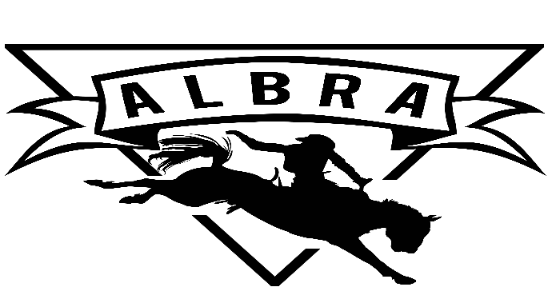
Member In Good Standing Checklist
- Membership application & Release completed and notarized
- Membership Fee paid
- Sponsorship due by December rodeos
- August – December work card due by beginning of January rodeos
- Raffle tickets due by April rodeos
- January – May work card due by end of May rodeos
- Competed in one more than half of the rodeos scheduled

